**Stat 502 Class Project Kaggle Scores Log**

**Team Kaggle Name:** tom_and_jerry

**Team Members (Names of non-502ers in Parentheses):**

Xiyuan Sun, Zhaoxin Lin, Dinesh Poddaturi

**Week 1 (March 26-30)**

**Team's Best Result/Public Score Thus Far:** 1.11867

**Date and Time:** 03/31/2018 at 12:30PM

**Team's CV Result for the Submission:** n.trees=160, interaction.depth=5, shrinkage=0.05, n.minobsinnode=7

**Screenshot of the Team's Best Score of the Week (Include Team Ranking and Score)**

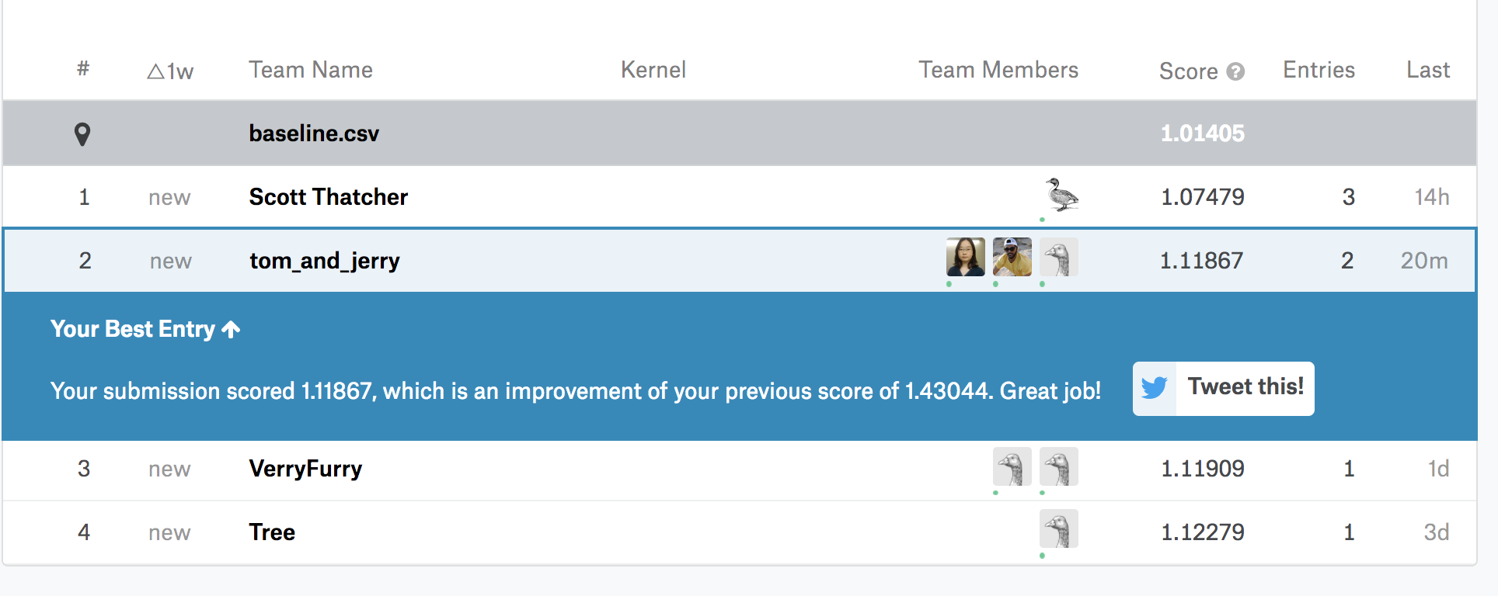

**Date and Time of the Screenshot:** 03/31/2018 at 12:48PM

**Number of Teams Registered at the Time of the Screenshot:** 4

**Week2 (April 2-8)**

**Team's Best Result/Public Score Thus Far:** 0.17160

**Date and Time:** 04/08/2018 at 9:30PM

**Team's CV Result for the Submission:** nrounds=2000, max_depth=4, eta=0.05, gamma=0, colsample_bytree=0.5, min_child_weight=1, subsample=1

**Screenshot of the Team's Best Score of the Week (Include Team Ranking and Score)**

